
THE WAY

The shared vision of all at King Alfred’s is to become an institution that aspires to every child within our academy experiencing an excellent education. King Alfred's will be an ambitious school at the heart of our community - everyone associated with our school will feel a distinct sense of belonging, pride and aspiration.
King Alfred's is a friendly, ambitious, and vibrant school packed full of energy, opportunity, and choice. Our mission statement is "Opportunity for All," something we believe in passionately and strive to deliver to our students each and every day.

School improvement objectives 2024-2027
Developing a culture of respect, participation and inclusion in all aspects of Academy life; everyone is warm, welcoming and friendly, routines are used across the academy to ensure consistency and staff are constantly asking ‘are they with me’?
To ensure that our curriculum is effectively planned and sequenced and assessment at all tiers is applied consistently, inclusively and effectively. In order to have impact on outcomes for all students across the academy.
To further develop the well-being and work life balance of all members of the KAs community, in order to ensure that we build a happy, safe and supportive environment in which all stakeholders are keen to work and to learn.
To create a school environment where students want to attend and be active participants in their education, ensuring that all student groups have an effective provision and are well supported

Self-evaluation
 | Grade 5 | Grade 4 | Grade 3 | Grade 2 | Grade 1
 | (Urgent Improvement) | (Needs Attention) | (Expected) | (Strong) | (Exceptional)
Curriculum and Teaching |  |  | ☑️
Inclusion |  |  | ☑️
Achievement |  |  | ☑️
Personal Development & Wellbeing |  |  | ☑️
Attendance and Behaviour |  |  | ☑️
Leading & Governance |  |  |  | ☑️
Post 16 |  |  | ☑️
Safeguarding | Met

Strengths
Behaviour and Ethos  - Values of Respect, Tolerance and Resilience well embedded. Supported by consistent routines and effective CPD for staff  - Excellent pastoral provision  - Low levels of classroom disruption  - Systematic use of attendance tracking data  - Effective communication drives cultural alignment  - Open door culture – typically 2000+ Learning walks and culture checks each year  - 3 year improving trend in attendance  - Reduction in PA (15%) and SA (20%)  - 60% reduction in suspensions and termly reduction since September 2024 |  | Curriculum and Teaching  - Curriculum and Teaching  - In depth curriculum and assessment review process completed with intent to deliver new curriculum and assessment strategy by September 2026  - Staff development is a priority. The Academy CPD programme is research based and aligned with priorities. Faculty CPD develops subject specialism  - High ratio of specialist teaching  - Improved staff retention  - Clarity of T&L approach  - Clear classroom routines, and a well embedded pedagogical approach (TIPI) is supported by effective CPD, coaching and learning walks |  | Post 16  - Consistently strong outcomes over last 4 years with positive ALP at A Level  - Positive destinations, significant success with UCAS support  - Broad programme of study  - Sophisticated academic enrichment programme
Leadership and Governance  - Strong safeguarding systems and culture  - Effective self-evaluation and improvement planning  - Demonstrable impact of change management – CPD/Culture/TIPI teaching cycle/Curriculum review  - Outward facing within Trust and wider in pursuit of best practice  - Consistently raising expectations of staff and students  - Focused work with LGC means that they have clear view of school, its strengths and areas for development |  | Inclusion  - Screening used to identify learning gaps and focus intervention  - Regular inclusion profile reviews  - Regular culture checks by LT support vulnerable learners  - Relevant targeted support programme (literacy/numeracy etc)  - Whole school CPD focused on supporting vulnerable learners – scaffolding key focus in current AY  - Wide range of adult support – TA/HLTA/Learning mentors/1:1 Tutors |  | Achievement  - Strong outcomes at KS5 and improving outcomes at KS4  - Positive P8 in 4 of the last 5 academic years, improving basics measure and use of FFT20 benchmarks  - A8/Basics above or at NA last 3 years  - Improving outcomes for PP students. Vulnerable learner outcomes generally in line with NA  - TIPI cycle supports checking for understanding in lessons    - Improved assessment accuracy allows leaders an accurate insight and better targeted interventions
Personal development and Wider Curriculum Offer
- Deeply impressive wider and super curricula offer; including student leadership, KA Klubs, residential trips, DofE and King Alfred’s Academic enrichment programme
- Character Development Award scheme
- Careers and work experience programme (KAreers Wanted). Gadsby benchmark 90%
- Broad pastoral support offer – Tutor, Student Manager, HoY, Youth Services, Counsellor
Impact of priorities
Achievement  - P8 consistently above zero and moving towards above average  - SEN resources and progress at KS4 improved  - Basics measure at KS4 atFFT20  - All subjects at KS4 above FFT50  - A*-B % at KS5 above 60%  - Assessment strategy implemented from September 2026 | Post 16  - Refresh and enhance vocational offer in light of whitepaper  - TIPI teaching cycle embedded in Post 16 practice  - Developed expertise in non-University routes  - Improved outcomes in priority subjects to at least ALPS 5 | Attendance and Behaviour  - Number of suspensions <500 and a reduction of 50% compared to AY 24/25and moving towards National Average  - Improving trend across whole school, PP and SEN attendance  - Attendance in line with National Average  - PA rate below National Average in AY 25/26  - Develop role of HLTA to supporting SA students  - Tutor role clear across school and central in developing sense of belonging and support
Leadership and Governance  - Positive staff wellbeing survey results  - Leadership standards understood and CPD supports more effective and consistent middle leadership  - Systematic tracking of impact in priority areas for improvement  - Develop leadership of support staff  -  | Personal Development and Wellbeing  - PSHCE curriculum review ensures relevance as well as interleaved curriculum that supports student’s development  - Tutor role clear across school and central in developing sense of belonging and support  - Systematic leadership response to tracking of engagement with wider curriculum supports universal access to our offer | Inclusion  - Effective communication drives greater parental satisfaction  - Inclusion engagement events embedded in academy diary  - SEN P8 gap closed and A8 increased  - The I in TIPI supported by CPD and Learning walks. Key. scaffolding strategies increasingly embedded in practice.  - Targeted support has impacts relevant and regularly reviewed. HLTA role builds in efficacy and impact  - Development of literacy and Oracy in curriculum removes learning barriers  - Reduction in teacher talk and passivity in lessons
Curriculum and Teaching  - Developing practice of tutors and classroom teachers so that students feel they ‘belong’ at KA’s  - Students experience success and are aware of the things we do as staff to support this  - Culture checks confirm that staff apply routines consistently and with warmth  - Middle leaders are consistent in leadership of teaching  - Outcomes of curriculum review are implemented from September 2026  - Curriculum review develops links at macro level to ensure clarity of learning and reduction in cognitive load for students |  | 
Key priorities for the year ahead
(specific focus from the three-year AIP objectives)
- Attendance and belonging – Improve attendance to above National Average and reduce PA numbers
- Reducing suspensions – Particularly in Year 8, 9 and for SEN students
- Inclusive teaching (TIPI) – Using the KA’s teaching approach to make our universal offer as inclusive as possible
- Developing middle leaders – Developing efficacy and confidence to drive improvement, coach and hold others to account
- Curriculum review and development – Plan and embed the agreed outcomes of the curriculum and assessment review
- Role of tutor – Daily Tutor sessions mean that we have the opportunity to develop this as a crucial aspect of our support for students

Our Values: ‘How we do things here’
At King Alfred’s, everything starts with our core values and our principles. Our behaviours are driven by our values of Responsibility, Tolerance and Respect, and our teaching and learning is characterized by our principles of Curiosity, the importance of Knowledge, and Resilience. These values drive the positive culture which is very precious to us, and all staff are expected to play their part in supporting our culture at all times.

- Responsibility - To take responsibility for our behavior, our words and our actions
- Tolerance - To show understanding and acceptance of those who are different, and to appreciate the uniqueness of all human beings
- Respect - To show respect for ourselves, each other, our school and our community
- Curiosity - To embrace the desire to learn all that we can about ourselves and our world by seeking out new ideas, experiences and viewpoints
- Knowledge - To appreciate that knowledge empowers everybody to lead a successful, independent and fulfilling life.
- Resilience - To develop the courage and resilience to respond successfully to challenges and to learn from failure
Our core values and our principles matter to us and drive our positive culture. They inform everything we do, from the behaviours we model around our sites, how we interact with one another, and how we communicate with our students through our assemblies, our lessons and all of our spoken and written conversations with our wider stakeholders.

At King Alfred’s Academy, our value of Respect is critical to our work as educators; we model this through courtesy and kindness towards each other, and in the polite manner with which we greet our students each and every day, and expect them to respond in kind. In this way, we create a culture that is ‘warm, welcoming and friendly’.

In addition, we have high expectations of our students and of each other. Consequently, we expect that our courtesy and kindness shown towards others is, in turn, modelled and mirrored by our students in all of their interactions with us.

Our Curriculum Vision: ‘How we do things here’

Our curriculum intent is designed to uphold our academy vision of ‘Opportunity for All’.

By this we mean that the curriculum includes not only a broad range of subjects from Y7 to 13, but also a rich variety of additional opportunities to learn and to develop through an enviable programme of extra-curricular activities, trips, visits, personal character development, and academic enrichment which are genuinely inclusive and open to all. At King Alfred’s, no student will ever be excluded from such activities owing to an inability to pay. Such opportunities include:

- Extra-Curricular Activities as part of our ‘Opportunity for All’ including a wide-ranging programme of sporting activities and Creative Arts events, participation in DofE and work-related learning.
- Extensive range of trips and visits within the UK and beyond.
- A Character Development programme and Student Leadership Programmes which support our six core principles.
- A unique Academic Enrichment programme which enhances the curriculum by offering diverse opportunities for students to develop their intellectual curiosity, critical thinking and understanding of the world.
Our curriculum vision is designed to support our core principles of Responsibility, Tolerance, Respect, Knowledge, Curiosity and Resilience.

Our curriculum aims to provide frequent opportunities for students to be intellectually challenged, to experience success inside and outside of the classroom, and to create a life of opportunity for themselves.

Our curriculum aims to provide an education that inspires ambition and promotes resilience, equipping students with the knowledge and skills needed to thrive in any environment. We prioritise building confidence and curiosity in each learner, ensuring that they feel empowered to overcome challenges and achieve their fullest potential.

Our mission is to inspire every student to reach their highest potential while helping them discover confidence in their unique talents and strengths. Together, we aim to build a community where each student learns to value themselves and others, fostering a sense of unity, respect, and purpose. Enrichment opportunities that deepen classroom learning are experienced by all students supporting our vision of ‘Opportunity for all’. Our curriculum design is based around 4 key principles which operate in synergy.

Broad and Inclusive
Our curriculum allows all students to explore a range of subjects across Key Stages by:
- Meeting and exceeding the demands of the National Curriculum
- Encouraging students to challenge themselves academically and personally
- Broadening student horizons and developing their cultural literacy
- Celebrating diversity and equality, helping students understand the world around them and their place in it
Coherent and Connected
Our curriculum is structured and sequenced so that:
- Students can develop a deep understanding of subject knowledge and skills
- It is cognitively demanding for all learners
- Skills and knowledge are thoughtfully spiralled and interleaved
- Cross curricula links are explicit and intentional
- It develops flexible learners with strong interdisciplinary understanding
Rigorous and Relevant
Our curriculum builds character, confidence and academic achievement, ensuring:
- Students learn that there are many ways to experience success
- Resilience, aspiration and agency over life are taught so that students become comfortable with the uncomfortable
- Students explore contemporary, relevant ideas
- Knowledge and skills can be utilised to solve problems, express themselves and think critically
Responsive
- The curriculum delivery is responsive in so much as teachers will regularly assess understanding and consider where and how to adapt to meet the needs of all learners. Our assessment is intentionally varied in design to promote important life skills that will provide the keys to success in post-16 education, employment, training and wider adult life. Students take responsibility for responding to assessment and learning from mistakes to drive forward their learning.

The wider curriculum
In addition, the curriculum vision at KAs embraces ALL of the opportunities on offer to our students, including not only the wide range of subjects at KS3 and KS4, but also the breadth of choice offered through what we call ‘Wider curriculum’: KA Klubs, extra-curricular activities, trips and visits, sporting fixtures, work experience, student leadership roles, academic enrichment programme, the King Alfred’s Character Development programme, performing arts events and the Duke of Edinburgh Award.

Students Leadership
There are a range of leadership opportunities for students at King Alfred’s. As a school, we are committed to giving students the scope to develop important leadership skills. The leadership opportunities are:
- Head and Deputy Head students (Sixth form)
- Year group student leaders (3 in each year group)
- Library ambassadors
- Community ambassadors
- Sport team captains
- Academy production student’s leadership team
- Cambrian Trust Youth Parliament

King Alfred’s Academic Enrichment Programme (KAAEP)
We are committed to offering a wide range of opportunities for our students to extend their academic learning beyond their work in the classroom. In addition to the faculty-led academic enrichment opportunities listed below, the King Alfred’s Academic Enrichment Programme (KAAEP) seeks to further broaden our student’s learning, giving them opportunities that go above and beyond the curriculum and so broaden their horizons.
We have a dedicated member of staff whose role it is to:
- Notify students and their families of academic enrichment and learning opportunities within our community and its surroundings.
- Arrange educational visits and workshops for groups of students.
- Organise evening talks (for students and families) from world-class speakers on a range of subject areas.
- Advise students in terms of independent learning and research.
- Provide added support with university applications, including applications to Oxford and Cambridge.

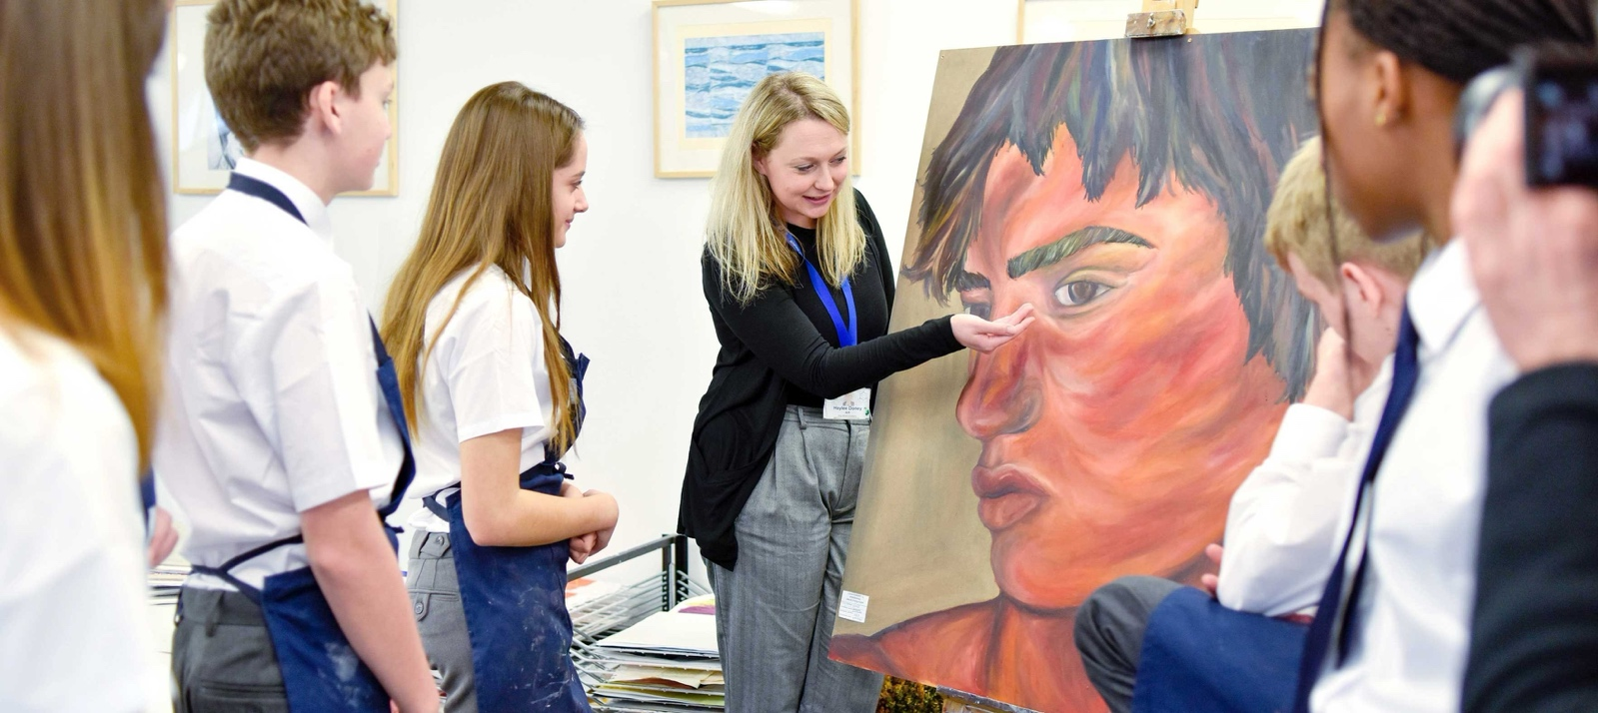

Our Pedagogical approach: ‘How we do things here’

Our intention for lessons at King Alfred’s is for them to be teacher-led, interactive, purposeful and Inclusive (TIPI). We endeavour to intentionally plan lessons to include all students and allow them to experience success. This is our universal offer to all students
We believe that our teachers are the subject experts, and for this reason we advocate that they generally avoid tasks that are ‘student-led’ as this often encourages students who have extensive prior knowledge to participate but disadvantages those whose general knowledge is not as developed yet, as well as allowing misconceptions to go unnoticed or uncorrected.
Teachers endeavour to ask students lots of questions during each lesson to check that they can put their learning into context; that they understand the teacher’s explanation; that they are listening attentively and are responding to others’ contributions in class. We use a range of methods to keep learning interactive in this way including mini whiteboards, ‘hands up’ and ‘half up’ (if they are less confident), ‘turn to your partner’ and ‘cold calling’ (where the teacher asks for answers without any hands up). Learning time is precious and we start every lesson with a subject specific starter so that no time is wasted.
We also strongly believe in the importance of routines as a way of building habits that establish a culture of attentive and respectful behaviour. These routines include how we enter a room; start a lesson; use mini whiteboards; listen attentively; contribute and end lessons. These are shared with students in assemblies and are taught in lessons to enable all students and teachers to make the best possible use of lesson time. As these routines become habits, this frees up any sense of ‘cognitive overload’ that students might experience or anxiety associated with variation that differences in routine can cause.
A King Alfred’s lesson is based on the following routines:
- Strong silent starts and warm greeting at the classroom door
- Warm reminders delivered using an agreed script
- Expectations clear set out and narrated – ‘if it is not clear, then it is not fair’
- A script for active listening (SELL) is used consistently
- Task design, checking for understanding and strategies for participation are intentionally planned
- Teachers scaffold the explanation of concepts and plan how to withdraw this when appropriate
- Ends of lessons are calm, positive and punctual. They provide an opportunity to recap and praise
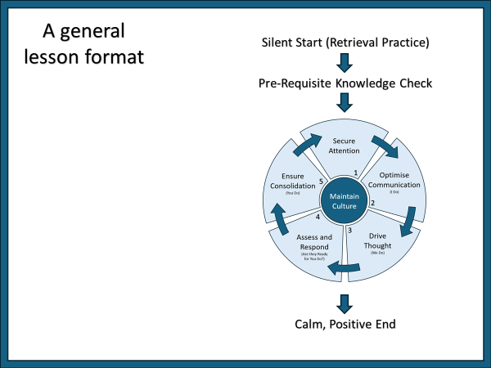
All staff at King Alfred’s are expected to take responsibility for their own continued professional learning, to engage with opportunities offered at whole school and Faculty level and to implement this into their teaching practice. Whilst there is always scope for teacher agency within the classroom, it is our view that there should be an evidence-based approach that ensures a commonality of approach and a predictable learning experience for all our students The King Alfred’s Teaching cycle

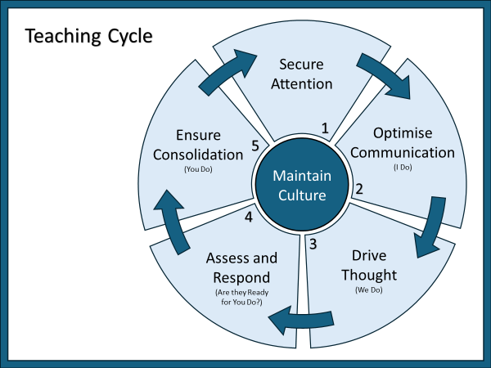

Maintain Culture – Kids don’t care what you know until they know you care.
Build belonging
- Be warm, welcoming and friendly when speaking to students, using open body language.
- Making it clear to students that you care about them as individuals.
- Ensure all students are included and feel valued (100% participation).
- Create a sense belonging by using group language “team”, “we” and “us”.
Have high expectations
- Use school routines for starts and ends of lessons.
- Make expectations clear to students for each phase of the lesson (‘if it’s not clear, it’s not fair’).
- Teach and narrate what good behaviour looks like.
Use praise and sanctions
- Celebrate students who demonstrate the school values (recognition board, verbal praise, house points).
- Praise should be personal, authentic and focused on the process not the outcome or performance.
- Give first attention to best conduct (75%+ positive interactions).
- Use the behaviour policy consistently and warmly (one reminder).
1 – Secure Attention – Attention is the gatekeeper of learning.
Create the right environment
- Ensure you are organised and have all equipment and resources ready to start introducing new learning.
- Ensure there is nothing in the physical environment that may distract students from key learning.
- Use the SELL routine to prepare students for attentive listening before any teacher explanation.
- Ensure 100% of students are attentively listening before moving forward with teaching.
Boost student buy-in
- Emphasise how what you are about to teach will benefit the students in the short term.
- Reassure students that explanations will be brief or broken up with questions.
2 – Optimise Communication – Working memory is the bottleneck of thought.
(I Do)
Reduce cognitive load
- Know what you want students to learn and how it fits together with other ideas.
- Break big concepts and complex skills into smaller atoms.
- Teach and secure understanding of each atom before building back up to the whole.
- Choose a pedagogical approach that is appropriate to the new learning which is being delivered.
- Deliver information concisely and enthusiastically.
- Model how to do everything (including logistics).
Support success
- Intentionally use whole class questioning techniques, with clear routines, to break up longer explanations and to check for listening (Choral Response, Cold Call).
- Provide a summary of the explanation at the end.
- Have steps and/or visuals that students can refer back to later in the lesson/in future lessons.
- Make it clear to students what success will look like.

3 – Drive Thought – Long-term memory is the residue of thought.
(We Do)
Ensure cognitive accountability
- Intentionally use whole class questioning techniques, with clear routines, to get all students to think hard about ideas and rehearse knowledge as a group (Mini Whiteboards, Turn to your Partner, Choral Response, Heads Down Voting, Cold Call).
- Ensure that you have 100% participation and narrate to students why this is important.
Slowly increase difficulty
- Balance the level of challenge throughout questioning (aim for 80% success).
- Initially give students opportunities to simply recall and verbalise new knowledge.
- As students become more confident, provide opportunities for students to: make links with prior knowledge; explain ideas in their own words; apply learning to new contexts; be creative.
- Reframe ‘getting things wrong’ as natural at this stage and a learning opportunity.
- Avoid asking students to copy – make every second count.
4 – Assess and Respond – If they get it wrong, then I will…
(Are they ready for You Do?)
Assess formatively with checks for understanding (CFU)
- Know what you are looking for (in terms of success and common errors/misconceptions).
- Know how to address specific misconceptions.
- Intentionally use whole class questioning techniques, with clear routines, to collect ‘data’ on student understanding (Mini Whiteboards, Heads Down Voting, Cold Calling of ‘backstop’ students).
- Check students have the necessary pre-requisite knowledge before introducing new content.
- Check understanding after each explanation to ensure students are prepared for independent work.
- Circulate and actively check student understanding during independent work.
Respond to ‘data’ by adapting the lesson
- Address mistakes/misconceptions immediately.
- Reteach key ideas where necessary.
- Check understanding again after reteaching.
- Identify students who will need scaffolding or challenge when the class moves to independent work.
- Highlight successes and narrate class progress.
- Reframe ‘getting things wrong’ as natural at this stage and a learning opportunity.
5 – Ensure Consolidation – Learning is a persistent change in long-term memory.
(You Do)
Embed learning over time
- Provide ample opportunities for students to practice/apply learning independently (in silence).
- Ensure that practice is varied so that students have opportunities to apply knowledge in a range of formats, question types, contexts, and difficulty levels.
- Provide opportunities for students to retrieve and apply learning in future weeks, months, years.
- Ensure that retrieval practice is spaced/interleaved in a way that is adapted to the needs of your class.
- Ensure students get feedback on independent work (self/peer/teacher marking).
Support all students to make progress
- Balance the level of difficulty (aim for 80% success).
- Provide scaffolds for students who are not yet ready to work completely independently.
- Have a plan to remove scaffolds over time.
- Provide challenge to extend the thinking of students who have a strong grasp of the core ideas.
Developing and investing in our staff: ‘How we do things here’
What CPD can I expect at KAs​ to help me develop as a teacher?
- All Teacher CPD | - KA Teaching essentials
- TLR CPD | - Step Lab coaching (1:1)
- Faculty (subject based) CPD | - Aspiring Leadership CPD
Associate Leadership shadowing programme
Type ​ | Compulsory and built into directed time?​ | When​ | Time​ | Purpose​
All Teacher CPD​ | Yes​ | Half-Termly ​ | 1 hour ​  3.30-4.30​ | To ensure alignment on culture and pedagogical techniques so that students get consistency.​
Department Faculty CPD​ | Yes​ | Weekly | 1 hour ​  3.30-4.30​ | To develop our teaching of our subject and​  to explore what whole school strategies look like​  at a department level.​
TLR Holder CPD​ | Yes​ | Half-Termly​ | 1 hour​  3.30-4.30​ | To align the expectations of TLR holders and​  to improve our impact as leaders.​
Teaching Essentials CPD​ | ECTs​  (All staff encouraged)​ | Fortnightly | 30 mins​ | To focus on mastering key aspects of teaching and routines that support us to all row together.​
Coaching ​  (Steplab)​ | Volunteers welcomed​ | 8-12 weeks | 30 mins weekly​ | To reflect on our practice and make positive, incremental changes to our teaching.​
Aspiring Leadership Team CPD​ | Middle Leaders welcome to sign-up​ | Half-Termly​ | 3.30-4.30​ | To develop skills to enable progression​  to a leadership position.​
Associate LT​  Opportunity​ | Middle Leaders welcome to sign-up​ | 10 weeks​ | 10 weeks​ | Opportunity to shadow a member of the leadership team, attend LT meetings and contribute ideas.​
Every Term had a balance of pastoral, cultural and pedagogical CPD. The year is always front loaded so that staff get more at the start than the end.
We run two whole school CPD session per half term – one for Heads of Year with their tutors and one to develop behaviour or pedagogical strategies.
Teachers also developed their subject knowledge and application in their faculty. This takes place in specific Faculty meetings 4 times each term
From September 2025 there are a number of CPD strands aimed to develop leadership competency and capacity with the Academy and prepare colleagues to excel in their middle leadership role and to prepare for the next step in their career.
We circulate an anonymous CPD survey every half term where we asked staff how useful and relevant they found the CPD and if they were able to apply it. We respond to staff voice and feedback
All staff have access to the National College on line platform. This allows them to access a range of high quality, relevant professional development.
All staff participate in the Cambrian Learning Trust Annual Conference. This provides a range of CPD and network opportunities
Our Staff Well Being Commitment: ‘How we do things here’
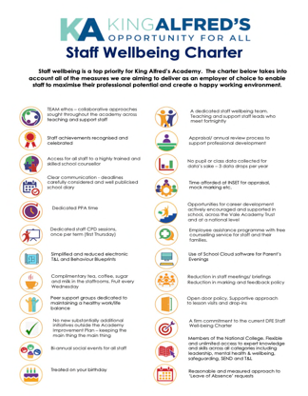
Staff wellbeing is a high priority for King Alfred’s Academy. We work as a close-knit team with a shared ethos of mutual support for each other. Random acts of kindness, courtesy and politeness typify the working environment at KAs.
The charter below describes all of the measures we aim to deliver as an employer of choice, to enable staff to maximise their professional potential and create a happy working environment.

Our Pastoral, Safeguarding and Community Care: ‘How we do things here’
Safeguarding
At King Alfred’s Academy, we are all committed to safeguarding and promoting the welfare of children and young people. We adopt a transparent approach to safeguarding, which encourages staff, parents and children alike, to talk openly and honestly about any concern or worries they may have about keeping children and young people safe. It is imperative that the academy is recognised as a safe place to be.
To ensure student safety remains a priority, staff report safeguarding concerns through CPOMS
We also have a Designated Safeguarding Lead (DSL), two Deputy DSL’s and a number of pastoral staff who are DSL trained and a Safeguarding Governor who can all be contacted via the safeguarding email:
At King Alfred’s Academy, we adhere to Safeguarding legislation in accordance with Keeping Children Safe in Education, and have a Safeguarding policy which details all relevant contacts and key information. We always encourage our staff to be ‘professionally curious’ and report any concern, no matter how insignificant it may seem, to our Safeguarding team.
Pastoral and Community Care
Pastoral and Community Care is a priority at King Alfred’s as we believe that a successful education starts with a partnership between the school, students and parents.
To support our students, we have an Inclusion Hub on both Centre and West Site, staffed by a comprehensive pastoral team made up of: Counsellors, a School Health Nurse, a Student Wellbeing Lead, a PSHCE Lead, Student Managers and Heads of Year.
Education and support are also afforded to students via assemblies, tutorial sessions and PSHCE sessions. We have a zero approach to bullying and are we members of the Anti-Bullying Alliance, United Against Bullying Programme.
To support our teachers, we offer bespoke training and education via CPD, INSET Days and our termly ‘Safeguarding Snippet’, which covers both current and emerging issues. We are committed to the Department for Education Wellbeing Charter and have, as a result, produced our own charter which embodies the academy’s key core values (see overleaf).
To support our parents, we deliver successful Community Wellbeing Events throughout the year, covering topics such as ‘How to have difficult conversations with teenagers’ and ‘Dealing with anxiety in children’.
We also provide guidance on how to support positive mental health and offer a ‘signposting service’ enabling parents to feel empowered in supporting their child/ren.
The role of the Tutor
Tutor time takes place at the same time each day and is a crucial point of contact and support for all students. The Tutor is the first point of contact for students and families, they are crucial in setting students up to learn each day and reinforcing the values of our Academy
Each week Tutors will deliver the following:
- Headteacher assembly and uniform/equipment check
- A reading/Literacy intervention session
- A Year group assembly
- A behavior and attendance focused conversation
- Topical news focus – ‘The world today’
- A quiz to promote connection

DEVELOPMENT PLAN 2024-7 “How can I contribute in my role?”
Developing a culture of respect, participation and inclusion in all aspects of Academy life; everyone is warm, welcoming and friendly, routines are used across the academy to ensure consistency and staff are constantly asking ‘are they with me’?
To ensure that our curriculum is effectively planned and sequenced and assessment at all tiers is applied consistently, inclusively and effectively. In order to have impact on outcomes for all students across the academy.
To further develop the well-being and work life balance of all members of the KAs community, in order to ensure that we build a happy, safe and supportive environment in which all stakeholders are keen to work and to learn.
To create a school environment where students want to attend and be active participants in their education, ensuring that all student groups have an effective provision and are well supported

ALL STAFF | TEACHERS & TUTORS | SUPPORT STAFF | MLT AND SLT | GOVERNORS
Everyone matters and makes a difference - everything we do at KA’s underpins each student’s success in the classroom and progression  We always talk about being on ‘the same team’  Our approach is Warm, Welcoming and Friendly  Honest and reflective approach to self-improvement as a colleague. We always engage with CPL opportunities and take responsibility for our own development  Attendance is everyone's responsibility, founded on high expectations and purposeful, engaging relationships to support a culture of belonging.  Everyone encourages punctuality between lessons.  Consistent expectations, praise, rewards and consequences applied by everyone.  We model our values with each other, students and parents/carers.  We always greet students and expect them to respond  We look out for each other and take responsibility for our own and others wellbeing | Visiting each other’s classrooms and looking beyond KA’s.  Research based culture and teacher community.  Engage the KA’s Teaching cycle (TIPI) to develop students’ participation and ensure lessons are inclusive  Teacher Standards and UPS drive reflection, self-improvement and CPL.  Sharing good practice, visiting each other’s lessons.  Regularly review inclusion profiles to ensure we know our students and their needs  We regularly assess students and check their understanding. Feedback is well planned and has impact  Welcoming classroom and corridor culture, we are always on the door to greet students  We relentlessly follow the classroom routines that underpin our TIPI approach and ensure good behaviour for learning  Expectations and routines applied with consistency.  Proactive around site and on duty. When we are on duty, this is our priority and we always engage with our students  Accentuate the positive with rewards and celebration.  Subject and pastoral follow up in line with agreed model.  Parental contact to build relationship and engagement | .  HLTAs, TAs and SEN team ready to play key role in supporting students in class and through interventions.  Teachers engage with HLTA and TA team effectively to support learning.  All classroom staff understand and implement agreed strategies with ambition for all  Every member of staff matters and makes a difference – all respected and supported to reward and address issues.  Support implementation of KA’s expectations and standards  Pastoral Team support specific students and families.  Administrative team provide the information and data required to allow classroom staff to fulfil their role effectively  Engagement with home and other agencies.  Help maintain a purposeful and positive learning and school environment. | Learning and culture check programme with consistent feedback loop to support quality of education  TLR training programme and development  ‘Constructive candour’ supports improvement. “We care enough to give and receive feedback”  Review curriculum sequencing, intent, implementation and impact. Always to deliver a better education for our students  In-depth understanding of our teams, their strengths and areas for development. Supported by effective line management and helpful appraisal  Collaboration with other schools at Trust and beyond – seeking out best practice | Use of triangulation questions for effective supportive and challenge.  School visits as part of triangulation and developing deep understanding of the school.  School data enables understanding and constructive challenge.  LGC engagement with SLT and MLT.  Reviewing reports of CPDL impact for staff.  Use of triangulation questions for effective supportive and challenge.  School visits as part of triangulation and developing deep understanding of the school.  School data enables understanding and constructive challenge.  Review surveys, student and staff voice.  Support strategic deployment of resources in order to ensure educational impact

