
Explore in Person
The Main Exhibition at the Ashmolean - How Plants changed our World
Available until 16th August 2026
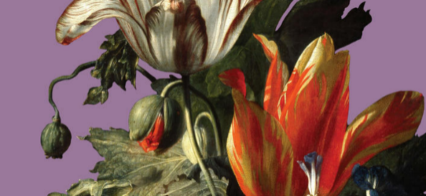
What do we really know about the plants and flowers in our gardens and window boxes?
Beyond their beauty, many have hidden histories – tales of exploration, obsession, and knowledge.
This major new exhibition takes visitors on a journey from Oxford to the farthest corners of the world and back, uncovering the global stories behind some of Britain’s most beloved blooms.
Featuring over 100 artworks and objects, including drawings, paintings, rare prints, and ceramics, In Bloom explores our changing relationship with the natural world.
From the fascinating stories of curiosity and ingenuity of early plant explorers to the networks that shaped global trade, this exhibition reveals how the pursuit of exotic plants transformed landscapes, economies, and cultures, leaving a legacy that still shapes our world today.
In Bloom is the first Ashmolean exhibition to consider sustainability from conception to delivery. Find out more
For more information, please refer to: IN BLOOM EXHIBITION | Ashmolean Museum
Please note: this exhibition has timed tickets, priced at £15.30, with concessions down to £7.65 for a 12-17-year-old child, and free entry for children under 12.

A few of the Free Exhibitions and displays at the Ashmolean:
(Please note: although entry to all of these exhibitions is FREE, it is advisable to book a free general admission ticket in advance. Please book your tickets at: EXHIBITIONS | Ashmolean Museum)

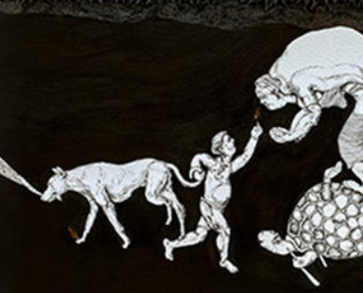 | Exhibition: Soma Surovi Jannat  Available until 1st November 2026  This exhibition showcases the work of Bangladeshi artist Soma Surovi Jannat, who draws inspiration from the Sundarbans, the largest mangrove forest in the world, and the Ashmolean collections to address the climate crisis.  Her art reflects on environmental issues and the interconnectedness of nature and humanity, especially in Bangladesh, where the Sundarbans, faces threats from climate change.  Gallery 8
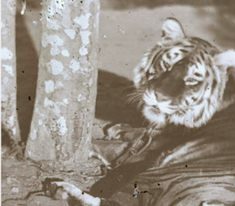 | Exhibition: Colonial Views of India  Opens on 11th April 2026  This is the first exhibition to focus on photographs and negatives in the Ashmolean, and as such features previously unseen photographs of India by Colonel Eugene Clutterbuck Impey (1830–1904).  A member of the East India Company, Impey arrived in India in 1851 and took part in military actions during the Indian Uprising of 1857. After the British Crown took control in 1858 following the Uprising, he worked as a political agent until returning to Britain in 1878.  Gallery 29
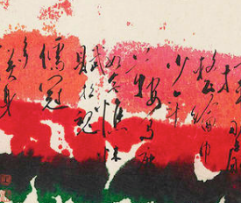 | Pat Suet-Bik Hui and the three Perfections  Available until 28th June 2026  Pat Suet-Bik Hui (b. 1943) is a US-based Hong Kong artist. This exhibition showcases her work alongside others who engage with the tradition of the 'three perfections', which brings together the three art forms of poetry, calligraphy, and painting.  The exhibition includes works by Hui, her contemporaries, her teacher Lui Shou-Kwan and others of his generation, as well as earlier examples.  Gallery 11.
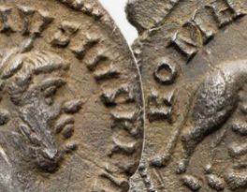 | Restoring Rome: Roman Oxfordshire Coins Display  Available until 29th November 2026  This collection of Roman coins is not usually on display and so it is a rare opportunity to see these Roman coins, all of which have been found in Oxford or the surrounding area.  Money Gallery

Explore at Home
Dive into the Ashmolean’s Collection of Short Story Videos
This is a great collection of short snippets that reveal more about some of the recent exhibitions, as well as some of the hidden stories behind some of the items in the Collections. Stimulating and thought-provoking. Do take a look! STORIES | Ashmolean Museum
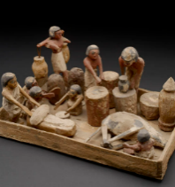
Have you looked at the Home Learning Section?
Ideal for KS3 exploration on a rainy day! Here you will find videos, short articles, photographs and things to make and do, on topics from Ancient Egypt to the Anglo Saxons, as well as jigsaw puzzles, Animal Crossing characters, and art and craft activities to do at home. HOME LEARNING | Ashmolean Museum

And if you are inspired to see more, then browse through the Ashmolean’s Treasures
You might retort that the whole of the Ashmolean Museum is filled with Treasures, so these items that are especially selected as the Museum’s Treasures must have great significance indeed, possibly because of their rarity, or the place they held at the time. Do take a look, and then maybe head over to the Museum to see them for real!
COLLECTION HIGHLIGHTS | Ashmolean Museum

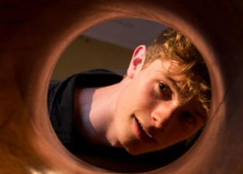
Explore online:
The Ashmolean for Young People
This is a great section to explore, with advice on the sorts of careers that you find within a museum (you might be surprised!!), as well as challenges and other activities to try out at home.
YOUNG PEOPLE | Ashmolean Museum

