Courses and Workshops

This new section is set aside for courses and workshops, both in person and/or online, which students are able to access independently. They are almost always offered by academic bodies with a mission to develop the intellectual potential of curious young minds.

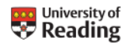
Subject Tasters from the University of Reading
You can catch up with some past subject taster webinars at: Subject tasters
English Language and Applied Linguistics - How AI is made to sound human and linguistic stereotypes

History - Religion in Britain during the First World War

Modern Languages Travelling Words: How and why European languages borrow from each other

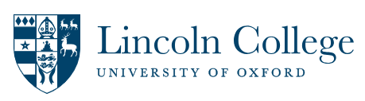
Subject Taster Days for Year 12 students
Lincoln College are again running in-person Study Days, for prospective students in Year 12 from state schools. The programme is designed to support students from non-traditional Oxbridge backgrounds who are on track to do well and potentially make an application to a selective university. There are four subject choices:
- Physics and Engineering
- Modern Languages
- English Literature
- History of the Ancient World.
For more information and details of how to register, please visit: Lincoln College Study Days | Lincoln College Oxford

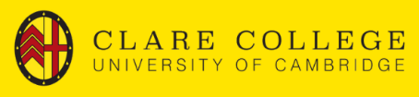
Exploring some of the lesser known Arts and Humanities subjects: (De)constructing Identity Webinars Series
This webinar series is specifically for State School students to explore those lesser-known subject options offered at University. This webinar series from Clare College Cambridge will run on Tuesdays and Thursdays during the month of March, and will include subjects such as Education, Classics, Asian and Middle-Easter Studies, and Modern and Mediaeval Languages. For more information and details of how to sign up, please visit: (De)constructing Identity: Arts and Humanities at University | Clare College - Cambridge University. Priority will be given to Year 12 students, but other age groups may apply. There are a couple of talks still left in the month of March!


University of Reading Short Online Courses
The University of Reading have designed and compiled a series of Short Online Courses to support students with developing their super curriculum. The courses range from history and sustainability to health and education, and will enable students to demonstrate a passion for their subject(s) as well as the ability to research and learn beyond the classroom. The courses are all free, and designed to be flexible and to fit in around other commitments. Take a look at what is on offer at: Short online courses

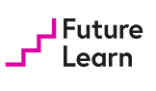
Future Learn – short online courses across a range of subjects
Another great resource for exploring your subjects beyond the curriculum. Great for checking that you really enjoy a subject enough to study it at university for 3-4 years, as well as providing you with sterling material for a personal statement. FutureLearn: Online Courses and Degrees from Top Universities

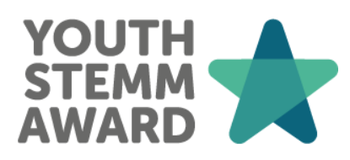
Youth STEMM Award
The Youth STEMM (Science, Technology, Engineering, Mathematics & Medicine) Award (YSA) is a flexible and personalised skills award for young people, empowering you to design your own programme of STEMM activities. Participants work towards a Bronze, Silver, or Gold Award by completing activities at school, at home, or online—choosing experiences that align with your interests.
Open to: students aged between 11 and 19
Introductory video here
Sign up here
Featured activity: choose a project and do research for NASA

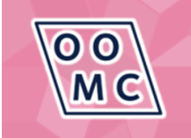
Oxford Online Maths Club
Online every Thursday, but you can access recordings at any time
Oxford Online Maths Club is a livestream from the Mathematical Institute, aimed at prospective students. The level of maths is therefore at A Level standard. It’s free, interactive, casual, and relaxed, and the livestreams are recorded so that you can watch back afterwards if you can't make it to the live broadcast on Thursday afternoons. To find out more, and to access past recordings, please visit Oxford Online Maths Club | Mathematical Institute

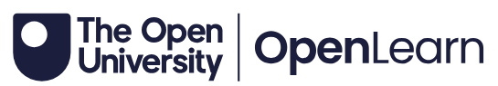
Free Courses from the Open University
There are over 900 courses to explore, most of which are 3-6 hours in length, and you can choose how you do the hours. From the evolutionary tree of mammals to the formation of exoplanets, and from understanding mental capacity to introducing public health, The range and scope of these courses is tremendous. Do take a look! Free short courses from the Open University | OpenLearn - Open University

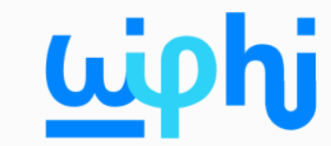
Wireless Philosophy – online course
If you are curious about philosophy, this course explores some of the main areas within the subject, as well as its history. This course's nuanced coverage of philosophical topics makes it an excellent companion to A Level and undergraduate psychology courses, and it can also be used by lifelong learners who are curious about modern applications of philosophy. Wireless Philosophy | Partner content | Khan Academy

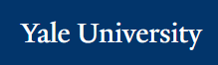
Open Yale Courses
This site from the prestigious Yale University provides free and open access to a selection of introductory courses taught by distinguished teachers and scholars at Yale University. The aim of the project is to expand access to educational materials for all who wish to learn. To find out more, go to Welcome | Open Yale Courses

