
From the Soldiers of Oxfordshire Museum
A small but excellent museum based in Woodstock! Well worth a visit, and there is much to explore online at its website: Soldiers of Oxfordshire Museum – Conflict & County


Recorded Online Talks
The Soldiers of Oxfordshire Museum has a fantastic collection of recorded talks, with titles including The Secret Life of Ian Fleming; The Pegasus Bridge Story and T.E. Lawrence: the Unconventional Warrior. You can find all three series of talks here: Online Talks – Soldiers of Oxfordshire Museum

The Museum’s permanent displays include:

- Winston Churchill and the Queen’s Own Oxfordshire Hussars
- Secret Spies, Secret Armies
- Prisoners of War, at home and abroad
- The liberation of Bergen Belsen by the Oxfordshire Yeomanry
- Bloody Battles and Dangerous Diseases
- Global Army: from the Age of Empire to the Modern Day
- Battles: the Oxfordshire and Buckinghamshire Light infantry during the Second World War
- A Woman’s War: domestic and fighting fronts
- Our Country, Our War – remembering the Great War

You can find out more about this museum at Soldiers of Oxfordshire Museum – Conflict & County

Temporary Exhibitions:
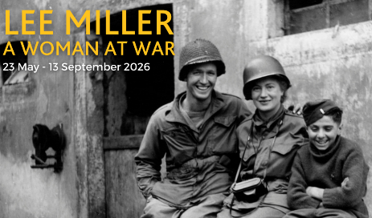
Lee Miller – a Woman at War
Available until 13th September 2026
Lee Miller (Vogue model, surrealist photographer and war correspondent) worked as a combat photographer with the US Army during the Second Worl War, creating a unique historical record. Lee Miller: A Woman at War Exhibition – Soldiers of Oxfordshire Museum

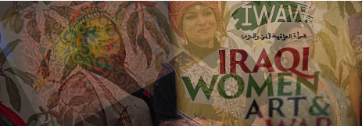
Women weaving stories in Sustainable Fashion
Available until 15th June 2026
The Iraqi Women Art and War Sustainability fashion exhibition highlights not only the beauty and craftsmanship of sustainability fashion, but also the strengths and solidarity of women using art as a tool for healing and empowerment.

You can find out more about this museum at Soldiers of Oxfordshire Museum – Conflict & County

