From the Bodleian Libraries
If you find yourself in the city of Oxford, why not take a walk down Broad Street and pop into the Bodleian Library to see one or more of the four Exhibitions listed below. All are FREE to enter, and you do not need to book beforehand.
Also, do take a look at the Events listings, as many of these are free to access as well. Please visit: Events & Exhibitions | Visit the Bodleian Libraries (ox.ac.uk)

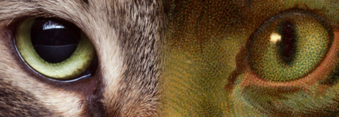
Exhibition: Pets and their People
Available until 27th September 2026
We have been domesticating animals for over ten thousand years. But why do we want tame wolves in our homes or wild cats on our laps? This exhibition explores the relationship between humans and their pets – or pets and their humans.
Pets & their People draws on depictions of pets in stories, imagery and poetry in the Bodleian's collection – from one of the earliest recorded depictions of an assistance dog for the blind to a rare copy of Alice’s Adventures in Wonderland that has never been displayed in the UK before. The exhibition asks how the special bond between owners and their pets has evolved over time, and what that evolution tells us about who we really are.
ST Lee Gallery, Weston Library

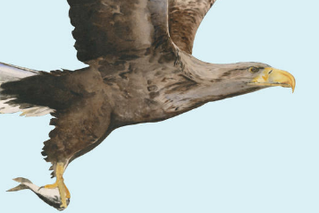
Exhibition: Wonder of Birds
Available until 3rd January 2027
Inspired by The Book of Birds by Jackie Morris and Robert Macfarlane, Wonder of Birds celebrates the splendour of the birds around us at the same time as recognising the steep decline in bird populations across our skies in recent decades.
Following the 'Seven Wonders' of birds – nest, egg, beak, song, feather, flight, migration – this exhibition pairs the words and art from The Book of Birds with Oxford ornithological research and Bodleian collections to explore the beauty and mystery of these extraordinary creatures.
For more information: Wonder of Birds | Visit the Bodleian Libraries
The Treasury, Weston Library. FREE Exhibition, no booking needed.
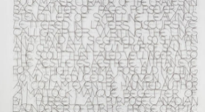
Display: A song of Myself
This is a wire sculpture by Tom Phillips RA, on long-term loan.
Blackwell Hall, Weston Library

Display: The Muddle of the Muses
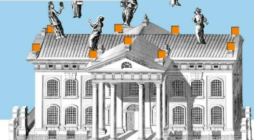
Available until 4th September 2026
Encounter the muses of history, epic poetry and rhetoric!
Blackwell Hall, Weston Library

You will find the full list at Events & Exhibitions | Visit the Bodleian Libraries

