And from the Natural History Museum of Oxford:


Special Exhibition: Opening in June – 34 Critical Raw Materials shaping our future
17th June 2026 – 13th April 2027
We use raw materials extracted from the earth in almost all of our technology, from smartphones to jet engines. These technologies, and the materials that make them, are critical to our ability to survive and thrive as societies. Global demand for these materials is growing rapidly as a result of our transition to green energy and increased reliance on digital technologies. Science and industry are urgently seeking more ethical and sustainable ways to mine vital raw materials, use them more efficiently, and recycle them effectively.
We hear about critical raw materials almost every day in our news feeds, but how do they actually fit into our lives? What are they? Why do we need them? Where do we get them from? And how will we get them in the future? Watch out for this exciting exhibition in the near future. . Find out more at 34: The critical raw materials shaping our future | Oxford University Museum of Natural History

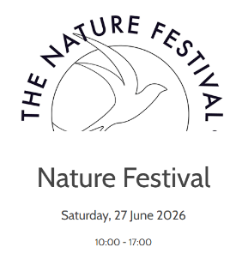
Drop-in Event – The Nature Festival
Saturday 27th June, 2026 10am – 5pm
Go along to the Museum to celebrate nature as they host Oxford’s Nature Festival. With stalls, talks, walks, films, music and art and craft activities all day, discover how people and organisations are studying, supporting and gaining inspiration from nature across Oxfordshire and beyond.
FREE event. Drop in. No booking required.


Explore in Person: New Displays now open
What connects prairie dogs to blister beetles? How do spiders communicate with each other? And why are cockatoos considered pioneers? Check out the new displays to find out. To get an online taste, please visit: Life, As We Know It | Oxford University Museum of Natural History

In addition, the museum has a number of events (talks, panel discussions, tours, workshops) over the coming months. Below is a selection, but do take a look at their WHAT'S ON | Oxford University Museum of Natural History to find a full listing. Many of their events are free, but most need to be booked in advance.

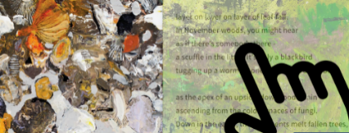
A Treasure of Online Exhibitions!
From Architecture to Animals, and from Bacteria to Brains, browse through the Museum’s collection of digital exhibitions and learn more about all aspects of the Natural World. Dive in at: Online exhibitions | Oxford University Museum of Natural History



The Learning Zone, from the University of Oxford’s Natural History Museum

This is packed with resources and ideas for learning about the Living World, the Earth, and Fossils. Most of the materials are aimed at upper KS2 and KS3, so if you are in Years 7-9, you should find plenty of interest: games, videos, activities, and ideas for further exploration. Do take a look! Home | The Learning Zone (ox.ac.uk)

The Natural History Museum has a number of regular family-friendly events, such as Science Saturdays, Autism-Friendly Openings and Family Friendly Sundays. Do take a look at their website to check out the whole programme of events: WHAT'S ON | Oxford University Museum of Natural History

The museum also holds regular sessions on object handling. To find out more, head to WHAT'S ON | Oxford University Museum of Natural History where you will find several pages’ worth of events.

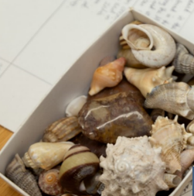
Young People at the University of Oxford’s Museum of Natural History
DO visit this section for ideas of how to get involved (e.g. the regular Youth

