At The History of Science Museum of Oxford:

The Museum is open between 12:00 and 5:00pm Tuesday to Sunday.
Please note that the top Gallery of the Museum is currently closed for essential maintenance, and that the lift is also out of action so there is no disabled access.

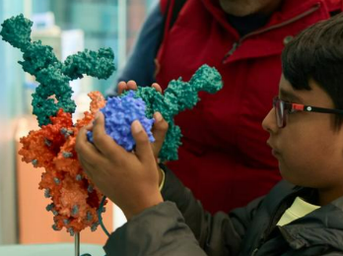
Exhibition: A healthy future for all? – Explore the science behind the pandemic headlines
To save lives during the COVID-19 pandemic, scientists took innovative approaches to produce rigorously tested, clinical-grade vaccines and drugs at speed.
But how can these new techniques deliver wider healthcare benefits for all of us?
A Healthy Future for All? empowers you to discover the science for yourself. Find out how the immune system works, and explore how researchers are using the pandemic experiences to prepare for the next pandemic outbreak.
A Healthy Future for All? | History of Science Museum (ox.ac.uk)

Exhibition: One Passion – A World of Histories
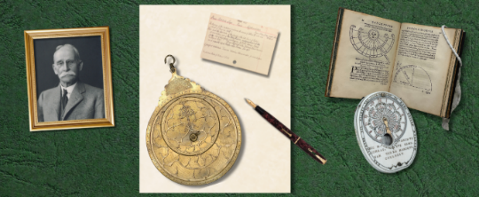
Why did a businessman like Lewis Evans build one of the finest collections of timekeepers from Europe and the Islamic World?
It started with a gift: a sundial, given to a 16-year-old Lewis by his eccentric father.
As he explored this ingenious instrument, Lewis discovered a world of histories: from the ancient science of time-telling to the bustling workshops of late 1600s Paris.
And he was inspired to learn more.
Over 50 years, Lewis built a collection to rival any museum, then or now.
From Persian astrolabes and German sundials to first edition books by Europe’s most influential mathematicians, he collected and researched them all.
Step into Lewis’ study and discover how to hold time in your hand.
To find out more, please go to: About Time | History of Science Museum

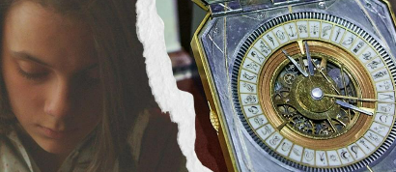
Exhibition: Step into Lyra’s Worlds – props and costumes from the BBC HBO series His Dark Materials

The History of Science Museum influenced the design of the Alethiometer. Come and discover your Daemon and journey through the Museum with your daemon guide to discover stories of creative leaders, resourceful adventurers, daring visionaries and ingenious scholars.
There are objects and stories to find as a family in each gallery before you enter the world of Philip Pullman’s international best-selling trilogy, His Dark Materials. Step into Lyra’s study, under a canopy of stars and Dust, to discover props and costumes from the BBC HBO production, including Lyra's alethiometer from the series.
Explore the Museum’s intriguing dials and devices that inspired Philip Pullman to create the alethiometer. Basement Gallery.


Alice in Typhoidland: The Past and Present of Typhoid
Discover the long history and cutting-edge research behind the typhoid vaccination and its roll-out.
Discover how Victorian doctors and scientists helped make typhoid visible and developed the first typhoid vaccines, and Learn about the current challenges of typhoid across the world and what researchers in Oxford are doing to tackle it.
To find out more about the Exhibition, visit: Alice in Typhoidland | History of Science Museum (ox.ac.uk)
You will find the Exhibition in the Basement Gallery.

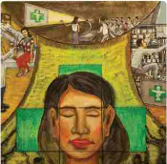
Display: The Disease of Greed – Fake, falsified and substandard medicine
Fake objects in museums may seem harmless, but fake medicines and misinformation have real consequences for all of us.
Come and investigate hoaxes, forgeries and fakes in the world of public health in Southeast Asia. Bear in mind that, although this display explores the problem in one area of the world, the issues arising are not confined to that area. Take a closer look online before visiting the display: 2024 Fakes Display (FINAL) (genial.ly)

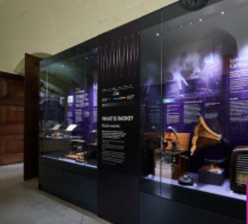
Meet Guglielmo Marconi – one of the minds who made the modern world
Through the work and experiments of Marconi, Radio was born.
This exhibition explains some of Marconi’s journey of discovery and its legacy in the terms of radio and microwave physics. Explore how Marconi’s science experiments revolutionised the way that the whole world stays connected.
Basement Gallery (You can also explore some the exhibition at home: Making Waves | History of Science Museum (ox.ac.uk) )

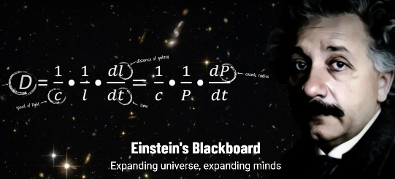
Display and Online Story Blog
One of the most famous artefacts on display at the History of Science Museum is Einstein’s blackboard, hanging high on the wall of the Basement Gallery. Visit
This blackboard is more than a glimpse into the mind of a genius, however: it is a key moment in our understanding of the Cosmos. To find out more, visit the online story here: Einstein in Oxford | History of Science Museum and, next time you’re in Oxford, pop into the museum to see the blackboard for yourself.

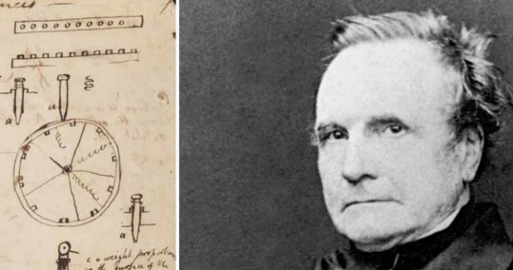
Blog: The Babbage Archive Project
The History of Science Museum holds important material associated with Charles Babbage (1791 – 1871) comprising: components of Babbage’s first (unfinished) mechanical computing machine; and an archive of his personal notes about his machines.
This project revolves around conserving and digitising this material. To find out more, please visit: The Babbage Archive Project | History of Science Museum

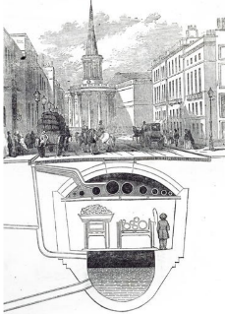
Blog – How Oxford’s Sewage Disposal System protects against epidemics
This is a fascinating read by MultakaOxford Volunteer Valerii Malko, a Professor of Philosophy from Ukraine. He starts his blog by saying “The problems of City Sewage were not originally my area of interest”. Read on to find out how this unlikely topic captured this professor’s imagination. Oxford's sewage disposal system protects against epidemics | History of Science Museum

Step back into online version of previous Exhibitions, dating back to the 1995!
The History of Science Museum has been creating virtual versions of their past Exhibitions for over 25 years – a real treasure trove of learning. Do take a look at:
Past exhibitions and displays | History of Science Museum (ox.ac.uk)

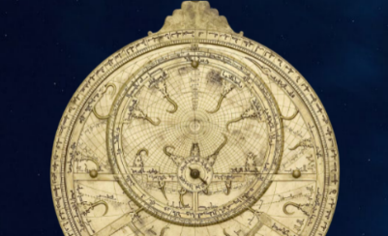
Online Exhibition: Mirror of the Stars
“Pick up an Astrolabe, and you hold the Universe in your hands.”
Join Museum curators Dr Federica Gigante and Mathilde Daussy-Renaudin to explore how astrolabes mirrored the traditional view of the Earth at the centre of our moving universe. This step-by-step tour of the Exhibition takes you through what astrolabes were and how they were used in so many aspects of everyday life. Visit: Mirror of the Stars | History of Science Museum (ox.ac.uk)

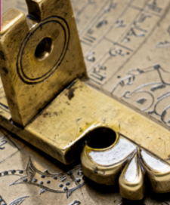
Read the Blog: Why our History Matters – a look at the decolonisation project that will explore the origins of the founding collection
Consider the role of museums in general and then explore the origins of some of the key collection artefacts, learn about the way the items were procured and discover some of the hidden voices and stories within them.
Finding and Founding Blog One Our History Matters | History of Science Museum (ox.ac.uk)

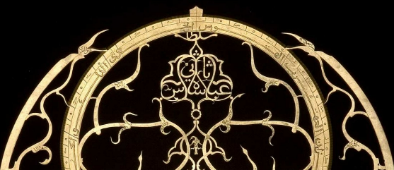
Discover the Collection: Science in the Islamic World
The History of Science Museum houses one the world's most comprehensive collection of astronomical instruments from the Islamic World.
Ranging from the 800s CE to the present day, these scientific objects were created and used by people living in lands where the majority religion was — or is — Islam. While the artisans who made them came from different regions — Europe, Africa, the Middle East and Asia — the objects themselves still share many similar, distinctive characteristics.
And though the instrument makers all lived and worked in the Islamic World, they were not all themselves Muslim. The result is a fascinatingly rich and diverse collection. For more information, please go to: Science in the Islamic World | History of Science Museum (ox.ac.uk)

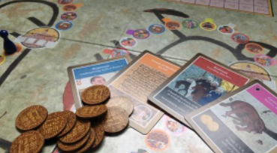
Watch again: the collection of recent past talks
Scroll down the page to reach the Museum’s Youtube collection of recent past events, which include a talk on Board Games and Mediaeval Medicine, and a discussion on whether science can always be considered “fact”.
What's on | History of Science Museum (ox.ac.uk)
You can also go on to take a virtual tour of the galleries at: Current Displays and Exhibitions | History of Science Museum (ox.ac.uk)

