Step into the Pitt Rivers Museum
Step into the Pitt Rivers and it is like stepping back in time, into a Museum ages past, where exhibits from all over the world crowd in on you from all sides. But the Pitt Rivers is totally modern in its outlook and seeks to represent the world in all its wonder and diversity. Booking is now only needed if you are attending a special event with limited numbers.

Explore in Person
In addition to the permanent Exhibitions, do take a look at some of the current temporary exhibitions and displays at the Pitt Rivers:

Exhibition – Hawaii: Ma Uka to Ma Kai
Journey through the Hawaiian landscape in this special exhibition, a unique collaboration showcasing the contemporary works of various artists and artist groups. With displays across the Museum linked to the Exhibition.
For more information, see Exhibitions and Displays | Pitt Rivers Museum

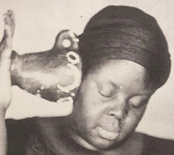 | Exhibition: In this Place we Breathe, by Khadija Saye  This exhibition presents a series of nine silkscreen prints by artist Khadija Saye (1992-2017) exploring her fascination with the ‘migration of traditional Gambian spiritual practices’ that formed a part of her childhood experience growing up in London with Gambian parents.  Upper Gallery
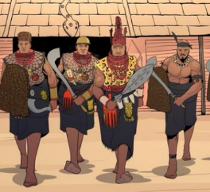 | Exhibition: Kingdom of Benin  This Exhibition highlights the glories of the Kingdom of Benin, also known as Edo, which was founded in 900CE. It tracks the history of the kingdom to its current form as a major Cosmopolitan City – the fourth largest in Nigeria.  Ground Floor Gallery  The Kingdom of Benin | Pitt Rivers Museum
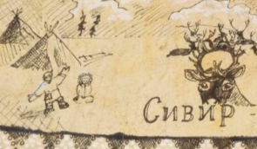 | Display: Wandering other Worlds  Explore Evenki Cosmology and Shamanic traditions through this display, but also the 360° video which you can watch online here: Wandering in Other Worlds PRM 2. You can find out more about this at: Wandering in Other Worlds: Evenki Cosmology and Shamanic Traditions  Display Case C.22.A (Main Court)
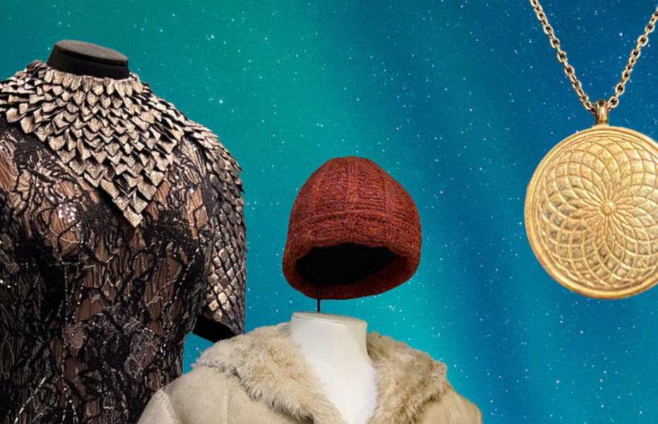 | His Dark Materials – Trail around the Museum  If you are a fan of Phillip Pullman’s His Dark Materials, and you watched the BBC HBO TV series, then do pop along to the Pitt Rivers as, dotted all around the galleries, you will find props from the series. To find out more, visit: His Dark Materials | Pitt Rivers Museum (ox.ac.uk)

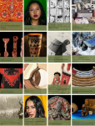
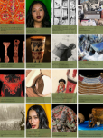
Online Archive: Curious about some of the Past Pitt Rivers Exhibitions that you may have missed?
You will find many of the past exhibitions here: Past exhibitions | Pitt Rivers Museum
Pitt Youth Action Team

Are you wondering what goes on behind the scenes at a vibrant Museum such as the Pitt Rivers? The Pitt Youth Action Team are a group of like-minded young people – typically aged between 16 and 19 – who meet at the Museum once a month. They are offered opportunities to have a real impact on the way the Museum interprets its collections, usually going behind the scenes to advise and consult with staff over exhibition materials, run activities at public events and plan projects.
If you would like to know more, please contact the young people’s co-ordinator at the Museum.

