Dear Parents and Carers,
We are excited to announce that we are holding our Ogden Partnership 'Physics Photography Phun' competition again. This competition is open to all children from Early Years to Year 9 in 3 different age categories. There is also an adult category open to all Ogden Partnership school staff and parents of children attending the schools. This year’s theme is
'Movement'

Rules of entry
- The photo must be taken by the child or adult entering the competition – therefore they should not be in the image.
- We hope to display copies of the finalist photos in a public place. By submitting your photograph to the competition, you give us permission to do this. Please ensure that you have permission of any people included in your photographs to submit their image.
- Only one entry per person.
- Age ranges: Early – Up to and including Year 2, KS2 – Year 3 to Year 6, KS3 – Year 7 to Year 9, Adult – parents of children in these age ranges, staff from Ogden schools.

How to enter
- Name your digital image file in this format: School abbreviation, age category, child/adult name, name of photo. Email subject should be: Photo, School abbreviation, Age range, competitor name.
- Send your digital image to your school's designated staff member before midnight on Wednesday 12th June 2024.
Your school information for file name:
School Abbreviation: KAA
Age ranges: Early, KS2, KS3, adult (early = Foundation to Y2)
Send to photos@ka.vale-academy.org
Example for Jo Witney in Year 9 at King Alfred’s : KAAKS3JoWitneyrunningpig.jpeg

Prizes and Judging
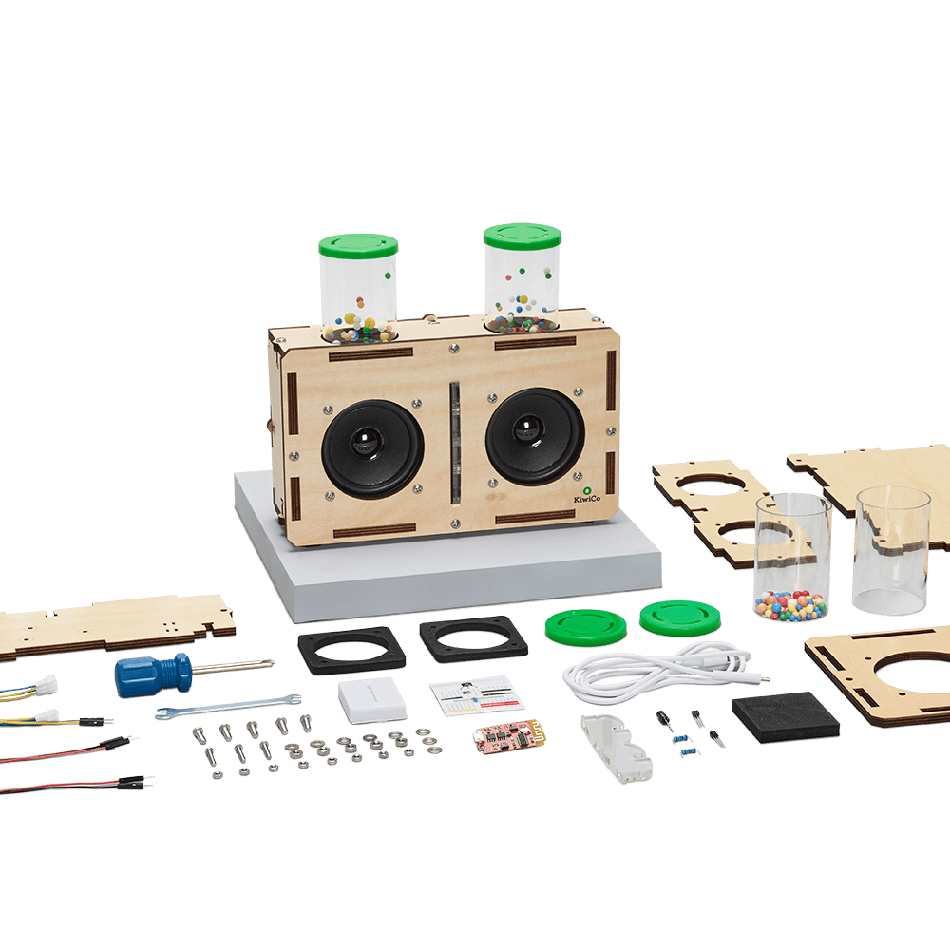
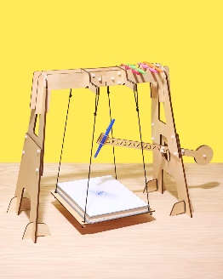

There will be winners in each age category for each school. They will win a small prize and a certificate. Their entry will then be entered in the partnership final where there will be one prize for each age group. This year’s prizes are:
Early age category – build your robot pets
KS2 age category: Build your own pendulum art maker
KS3 age category: Build your own light up speakers
Adult category: £50 gift voucher for the Winchester Science Centre and Planetarium.

The in-school child competitions will be judged by staff in the school. Judges will only know the age range, not the name of the children. The finals will be judged by our regional representative from the Ogden Trust and 2 other impartial judges (one a professional Photographer and one a Physicist at RAL). The judges are looking for images that show the science of the theme, that are interesting to look at and are appropriate to the age group.
We hope that you have a fun half term with this ‘moving’ activity. Good luck.

Best wishes,
Cat Boaz
Primary Stem Specialist Teacher, Vale Academy Trust
Ogden Trust South Partnership Lead

